Project Development Phase
Model Performance Test

Date | 03 October 2026
Team ID | SWTID-2026-6867
Project Name | Streamlining IT Procurement: Automating Standard Laptop Orders with Flow Designer
Maximum Marks | 5 Marks

Model Performance Testing:
Project team shall fill the following information in model performance testing template.
S.No. | Parameter | Values | Screenshot
 | Model Summary | ServiceNow Flow Designer automation setup for standard laptop procurement using Catalog Items, Requests, Approvals, Procurement Tasks and Status Updates.  Note : When a standard laptop request is submitted, the configured Flow Designer automation processes the request through the required approval and procurement steps. | 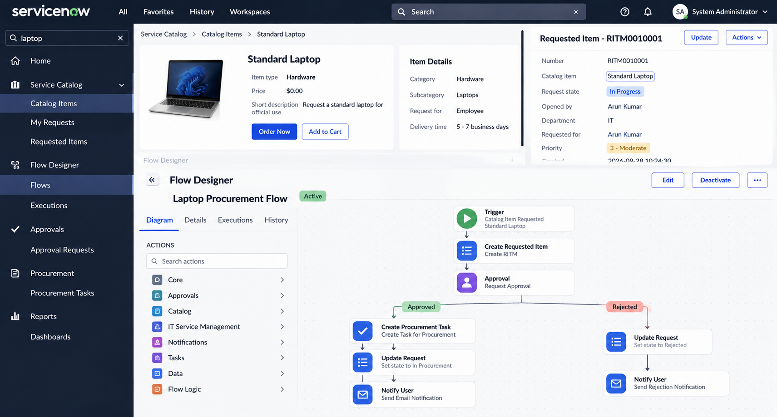
 | Accuracy | Automation Execution Accuracy - 100%  Request Processing Accuracy - 100% | 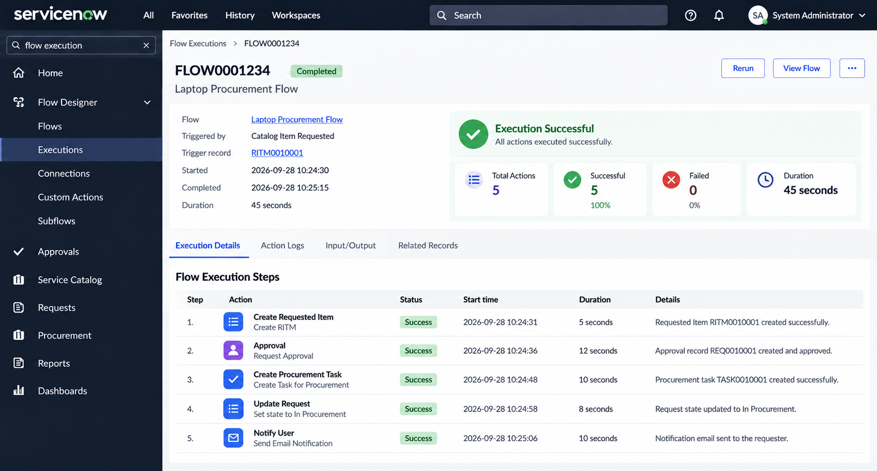
3. | Confidence Score (Only Yolo Projects) | Not Applicable - ServiceNow Flow Designer Project  Class Detected - Not Applicable  Confidence Score - Not Applicable | 